INSERT Your Company Logo Here 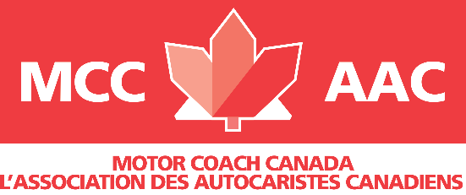 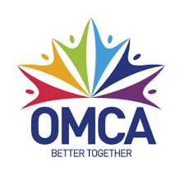
ADD - Today’s Date

Dear; ADD ELECTORAL CANDIDATE’S NAME
We would like to begin by thanking you for your continued strong advocacy and support for the tourism sector throughout the pandemic.
I am writing to you today to bring to your attention an urgent and critical matter for members of the Ontario Motor Coach Association and of Motor Coach Canada.

The extension of the Canada Emergency Wage Subsidy (CEWS) and the Canadian Emergency Rent Subsidy (CERS) until October 2021 is a small but positive step in supporting hardest hit businesses who have lost most of the summer and still suffering from travel restrictions, border closures and mass gathering restrictions. While we are supportive of the initiative, this extension alone will not save many of the hardest hit businesses from financial ruin this fall and winter. Our association members participated in a national business pulse survey in June which shows that nearly 60%
of tourism hardest hit businesses will not survive if CEWS and CERS are not extended to beyond the end of the year.

We are calling on you today to support the following priorities:

- SUPPORT A TAILORED WAGE AND FIXED COST SUPPORT PROGRAM to support hardest hit business until summer 2022. The wind down of CEWS and CERS jeopardizes Motor Coach business across Canada. We believe that tailored support program exclusively for hardest hit businesses in our industry represents a low risk for the government. In fact, over 95% of the economy is experiencing recovery, and only sectors that are truly the hardest hit would remain eligible for a tailored program.
- INTRODUCE SPECIFIC ECONOMIC RELIEF FOR MOTOR COACH TRANSPORTATION SERVICE PROVIDERS - Countries around the world are safeguarding their motor coach sector. The U.S. Department of Treasury introduced a Coronavirus Economic Relief for Transportation Services (CERTS) Grant Program that will provide grants to eligible motor coach companies and other transportation service providers that have experienced annual revenue losses of 25 percent or more as result of COVID-19.
- REDEVELOP A NATIONAL COAST TO COAST MOTOR COACH NETWORK to reconnect communities and Canadian’s no longer serviced by bus or train or cut off from essential services. Motor Coaches provide Canadians with an affordable, safe, and environmentally responsible way to connect our country.

Canada’s motor coach and group travel segment accounts for over 30% of the tourism visitations. Canada’s visitor economy relies on motor coach and group passenger transportation. These visitors contribute approx. 30% of the $105b in Tourism tax revenues collected annually by the federal government.
Without continued and enhanced support for our industry, Canada’s tourism sector will not have the transportation support needed to move visitors as safely, responsibly, and expediently as needed, and Canadians in rural communities will lose the most cost efficient and environmentally responsible means of transportation.
I thank you for your time and consideration to this most important issue.

Sincerely,

ADD YOUR NAME
ADD YOUR TITLE
ADD COMPANY NAME

CC:
Vince Accardi, President OMCA and MCC

